**Experimental procedure (Study 3)**

We would like to investigate under what circumstances belief in Jewish conspiracy theory would affect participants’ belief in vaccinations.

**Procedure:**

1. PIL and informed consent
2. Belief in Jewish Conspiracy scale
3. Threat vs non-threatening condition (randomised)
4. Symbolic threat scale (manipulation check)
5. Religious authorities endorse vs oppose coronavirus vaccine (randomised)
6. Manipulation check
7. Vaccine conspiracy belief (d.v)
8. Outgroups vs ingroups blame
9. Attention check
10. Demographic questions
11. Debriefing

**Hypothesis**

1. Participants whose identity is threatened and when the coronavirus vaccine is opposed/objected by the Islamic clerics, are more likely to endorse vaccine conspiracy theories

Model for testing hypothesis 1: VCB = BJC + IT + RE + (BJC*IT) + (BJC*RE) + (IT*RE)

VCB: Vaccine conspiracy beliefs; BJC: Belief in Jewish conspiracy, IT: Identity threat; RE: Religious authorities vaccine endorsement

Analysis: Bootstrapped Moderated Regression – 10.000 iteration

1. Participants who blame the outgroups (the Jews, the Chinese-Indonesian, and the China nationals) in regards to coronavirus problems would be more likely to refuse coronavirus vaccination
2. Participants who blame the ingroups (the Muslims and the Indonesia nationals) in regards to coronavirus problems would be less likely to refuse coronavirus vaccination

Model for testing hypothesis 2: RV = BJ + BCI + BCN + BM + BI

RV: Refuse vaccination; BJ: Blame the Jews; BCI: Blame the Chinese Indonesian; BCN: Blame in Chinese Nationals; BM: Blame the Muslims; and BI: Blame the Indonesians

Analysis: Bootstrapped Multiple Linear Regression – 10.000 iteration

**(2x2) Block randomization:**

|  |  |
| --- | --- |
| Threatening & vaccine endorsed by Islamic clerics  (intervention vs control)  (Group 1) | Non-threatening & vaccine opposed by Islamic clerics  (control vs intervention)  (Group 2) |
| Non-threatening & vaccine endorsed by Islamic clerics  (control vs control)  (Group 3) | Threatening & vaccine opposed by Islamic clerics  (intervention vs intervention)  (Group 4) |

Page order for randomisation (Block Randomisation)

1. IC: 'p5-p7', 'p9-p15', 'end'
2. CI: 'p6', 'p8-p15', 'end'
3. CC: 'p6-p7', 'p9-p15', 'end'
4. II: 'p5-p6', 'p8-p15', 'end'

PHP code for applying gender matching 🡪 equal proportion of male and women for each cell

if(value('DE06') == 1) {

urnDraw('laki-laki', 'RM01', 'end');

} else {

urnDraw('perempuan', 'RM01', 'end');

}

// show pages

$number = value('RM01_01');

if($number == 1){

setPageOrder('p5-p7', 'p9-p15', 'end');

} elseif($number == 2){

setPageOrder('p6', 'p8-p15', 'end');

} elseif($number == 3){

setPageOrder('p6-p7', 'p9-p15', 'end');

} elseif($number == 4){

setPageOrder('p5-p6', 'p8-p15', 'end');

}

All codes are in p4, placed after BJC scale

**Stimulus: Identity Threat**

***Threatening Conditions***

***Apart from detaining minors, Israeli soldiers have been condemned for attacking the Aqsa Mosque***

Beritatiga.com – Over the past three months, Israeli soldiers detained and tortured at least 300 underage children. Middle East Monitor, an organization that advocates for human rights issues in the Middle East region, issued a shocking report on that fact. During 2019 alone, the Israeli army captured at least 7,000 Palestinians living in the Gaza Strip and nearly half were child detainees aged around 6 to 17 years. Some media have called the Israeli army "inhuman", "beyond normal", and "barbaric actions”.

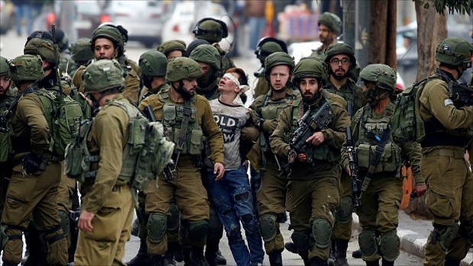

In addition to that, last month, Israeli soldiers with heavy weapons stormed the Aqsa Mosque and engaged in clashes with Palestinian Muslims who were worshiping around the mosque. As a result of the clash, 5 civilians were reportedly shot dead while 33 other residents were seriously and lightly injured - 11 of them women and children. Israeli soldiers reportedly destroyed mosque property, frightening residents who wanted to worship with firearms, even spitting and burning worship equipment available in the mosque. This barbaric act invited widespread condemnation from the Muslim community throughout the world.

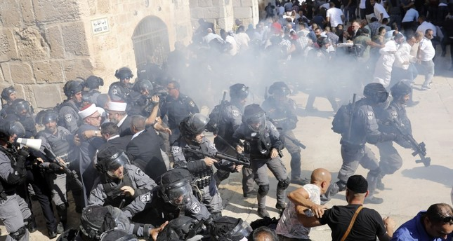

**Stimulus: Religious Authorities Endorsement**

***Endorsed by Islamic Clerics (treatment)***

**Meeting the needs of the coronavirus vaccine, Biofarma is collaborating with an Israeli vaccine company**

Beritatiga.com – To reduce the rate of coronavirus transmission, researchers working at Biofarma collaborated with BiondVax, a vaccine manufacturing company from Israel to produce a coronavirus vaccine which is expected to be finished its clinical trials by the end of July 2021.

Tamar Ben-Yedidia, owner of BiondVax, is the sole patent holder of MortelVax, a coronavirus vaccine that produces a high level of immunity, which is almost 98 percent.

With this collaboration, PT Biofarma hopes to develop a coronavirus vaccine formula that produces high levels of immunity to meet national needs, bearing in mind that Indonesia has not been able to produce vaccines independently.

This collaboration **is also facilitated by** the Food, Drug and Food Assessment Institute (LPPOM) of the Indonesian *‘Ulema* Council (MUI). KH Lukmanul Hakim, Director of LPPOM MUI, greatly welcomes and hopes that this collaboration could support government programs in protecting the Indonesian people from the dangers of the coronavirus.

***Not endorsed by Islamic clerics (control)***

**Meeting the needs of the coronavirus vaccine, Biofarma is collaborating with an Israeli vaccine company**

Beritatiga.com – To reduce the rate of coronavirus transmission, researchers working at Biofarma collaborated with BiondVax, a vaccine manufacturing company from Israel to produce a coronavirus vaccine which is expected to be finished its clinical trials by the end of July 2021.

Tamar Ben-Yedidia, owner of PT BiondVax, is the sole patent holder of MortelVax, a coronavirus vaccine that produces a high level of immunity, which is almost 98 percent.

With this collaboration, PT Biofarma hopes to develop a coronavirus vaccine formula that produces high levels of immunity to meet national needs, bearing in mind that Indonesia has not been able to produce vaccines independently.

This collaboration **is also facilitated by** the Indonesian Ministry of Health. Terawan Agus Putranto, Minister of Health, greatly welcomes and hopes that this collaboration could encourage government programs in protecting the Indonesian people from the dangers of the coronavirus.

However, The Food, Drug and Food Assessment Institute (LPPOM) of the Indonesian *‘Ulema* Council (MUI) responded coldly to this collaboration. KH Lukmanul Hakim, Director of LPPOM MUI, expressed his concern that this cooperation will ignite controversy among Muslims because it involves Israeli vaccine producers.

**DEBRIEFING**

The article entitled "Meeting the needs of the national vaccine, Biofarma coupled with pharmaceutical companies from Israel" **is entirely fictional** and **deliberately created by the researchers** as part of this experimental research.

**IN FACT:**

1. **Biofarma** manufactures vaccines independently
2. Although BiondVax (vaccine manufacturer from Israel) does really exist, the company **has never produced a coronavirus vaccine** but rather seasonal influenza vaccine
3. The Ministry of Health or LPPOM MUI **has never facilitated cooperation** between Biofarma and BiondVax
4. Until now, there **has not been a single** company or research institution that **has succeeded in producing** a safe and ready-to-use coronavirus vaccine